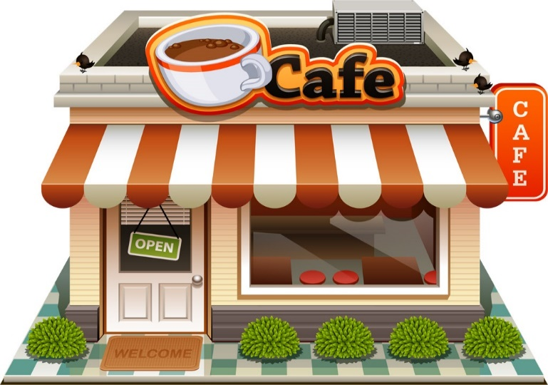Restaurants
Pizza Ranch of Clarion
102 South Main Street, Clarion, IA 50525
(515) 532-3215
La Tienda Mexicana
116 South Main Street, Clarion, IA 50525
(515) 532-2222
Chappy's On Main
122 South Main Street, Clarion, IA 50525
(515) 532-2727
Grounded (closed Saturday)
118 North Main Street, Clarion, IA 50525
(515) 602-6212
Wed-Fri 7 am – 1 pm
Fuel
223 North Main St., Clarion, IA 50525
(515) 532-3835
Sam's Chinese Kitchen
104 Central Avenue East, Clarion, IA 50525
(515) 532-2989
Casey’s Pizza, Subs & More
222 Central Ave, Clarion, IA
515-532-3030
Subway
316 Central Avenue West, Clarion, IA 50525
(515) 532-6917
Hardees
329 Central Ave. West, Clarion, IA 50525

Wildwood Café
Located at Iowa Specialty Hosp.
1316 So. Main St, Clarion, IA 50525

Timbukbru
215 6th St. SW, Clarion IA
515-532-0015
Opens 3pm; craft beer, local wine only
Restaurante El Morelense
1218 Central Ave. E
Clarion, IA 50525
(515)851-5296

Groceries
Brothers Market (and deli)
325 Central Avenue West
Clarion, IA 50525
(515) 532-2829
Granny’s Iowa Market
202 North Main Street, Clarion, IA 50525
(515) 532-2788
Purple Ribbon Beef
1788 200th Street, Clarion, IA 50525
(515) 571-2758

